Mount St Bernard College, Herberton, Queensland

Our History
2010 marks a century of Catholic Education in Herberton. Having already founded St Patrick’s Catholic Primary School in 1910, the Sisters of Mercy established Mount St Bernard College in 1921 as a boarding college for both primary and secondary students. The main priority of the college was to meet the educational needs of students from remote areas of the Far North and Northwest of Queensland.
The foundation stone of Mount St Bernard College was laid on January 11, 1920, and the College was officially opened on September 21, 1921.

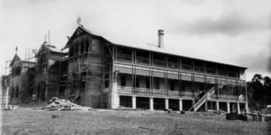
Mount St Bernard College under construction
The College is named after Fr Bernard Patrick Doyle, who had come from Ireland in 1906, as it was his idea to establish a boarding school on this part of the Atherton Tablelands. Fr Doyle had a dream of one day establishing a boarding school in his parish and many times discussed his idea with the sisters.

In its first year of operation some of the forty-six boarders were primary school students who attended St Patrick’s School while the remainder were secondary students and were taught in Mount St Bernard College.
In the early years the College catered for the primary education of boys as well as girls until St Patrick’s closed in 1977.
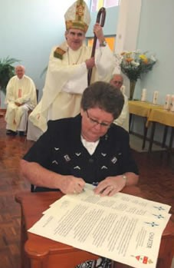
2006 The Mercy Sisters gift Mount St Bernard College to the Catholic Diocese of Cairns

Throughout the twentieth century, Mount St Bernard College has responded to the changing needs and aspirations of students and their families. The College even hosted Cooktown’s St Mary’s School during a period of World War II evacuation. At every stage, MSB has provided opportunities for quality Catholic education to the young people of the Far North and beyond.
In 2006, the Sisters of Mercy gifted Mount St Bernard College to the Catholic Diocese of Cairns. MSB is now under the stewardship of the Cairns Diocese’s Catholic Education Services and the Mercy charisms of service, faith, hospitality and social justice continue to be nurtured and lived out by a dedicated and professional staff.
In 2009 Mount St Bernard College entered a new era of revitalisation and renewal.

http://182.160.153.247/~centenarymsbqlde/index.php

Welcome to MSB 100 Years
Centenary introductory video - click here
Mount St Bernard College has a proud history which is intrinsically linked to the heritage and charism of the Sisters of Mercy.
Originating in the heart and mind of the Parish Priest of the time, Fr. Patrick Bernard Doyle more than 100 years ago, and enlivened by the Sisters of Mercy from it’s inception, Mount St Bernard College has evolved to meet the needs of the time.
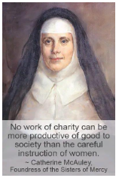

As the foundress of the Sisters of Mercy, Catherine McAuley, did in Dublin nearly 100 years prior (1824), Fr Bernard and the local Sisters built a large ‘House of Mercy’. Catherine stated that “no work of charity can be more productive of good to society than the careful instruction of women’ and it was with this care and nurturing spirit that the Sisters of Herberton set about providing this ‘instruction’.
At the heart of the Mercy charism, I believe, is love: love entrenched in the Gospel. Catherine had many sayings that exemplified this, including: “ ‘Love one another as I have loved you.’ This was the special command of Jesus Christ .... which as a most valuable legacy, He bequeathed to all His followers”1. With this love in their hearts, the Sisters worked tirelessly to provide quality education and care.
The ministry of the Sisters of Mercy from those early days at Mount St Bernard College, till when the last sisters ceased residing at the College in 2018, has evolved and adapted to the times. The “Sisters of Mercy are eminently practical and over time have translated their tradition and their vision into tangible expressions of the Gospel”2.
The lay staff of Mount St Bernard College are now charged with this legacy and must likewise evolve and adapt with the times. We must ‘be mercy’ in the world and particularly those we educate at the College so that we continue to “empower young people through our commitment to education to become persons of faith, learning and hope, and so contribute to their communities”3
It is a special legacy which many people have been a part of whether that be as Sisters of Mercy, lay staff, students, or friends of the College.

Weblinks to MSB College timeline: MSB College Timeline
Weblink to MSB Mercy Museum: MSB Mercy Museum
Weblink to MSB Mercy Trail: MSB Mercy Heritage Trail
Weblink to Gallery of Images: Gallery
Link to College Website: https://www.msb.qld.edu.au/

