Mercy International Association
Official Logo for the 200th Anniversary of the Founding of Catherine McAuley’s First House of Mercy
Guidelines on use and copyright information
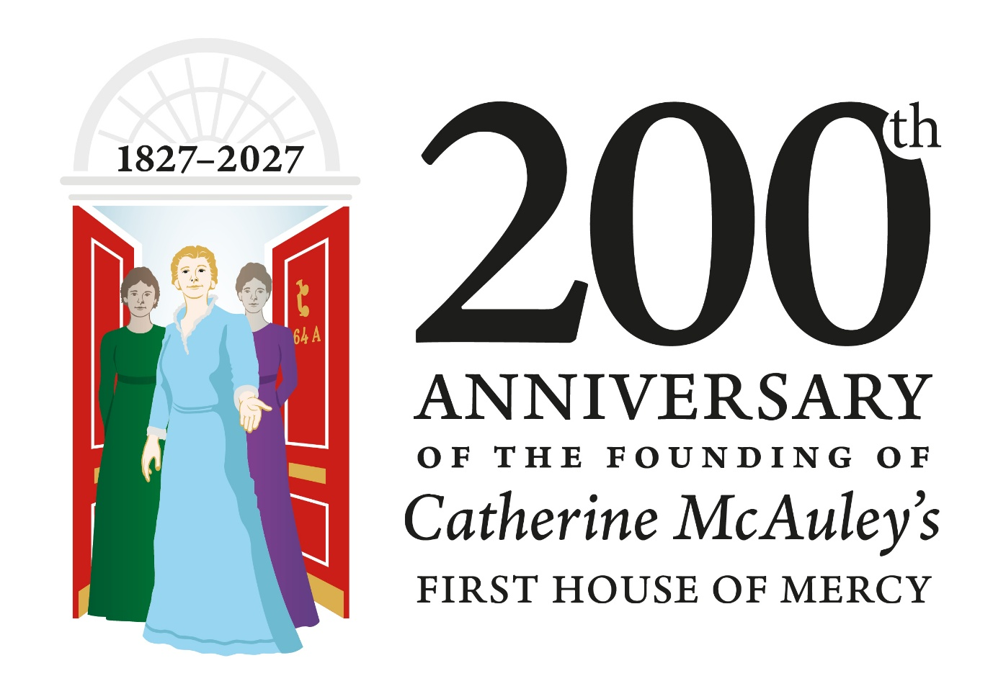
On 24 September 2027 we will mark the 200th anniversary of the Founding of the First House of Mercy by Catherine McAuley at 64a Lower Baggot Street in Dublin.
We have created the official logo for the bicentenary campaign which is shown above.
Copyright
The logo is copyrighted to Mercy International Association (MIA) and may not be downloaded or reproduced without permission. A logo kit is available by request for Mercy Organisations - all queries should be sent by email to mercyenews@mercyinternational.ie .

Explanatory Note on the Logo
This anniversary logo is rich in historical and symbolic meaning. Catherine McAuley is pictured as a lay woman, depicted in Mercy blue. Her position just to the front and centre signals her role as founder and her openness to those she served.
Her welcoming gesture reflects the original purpose of the House of Mercy: to provide shelter, education, and dignity to women and children experiencing poverty.
As well as representing a welcoming in, Catherine’s outstretched hand also denotes her sending out too.
There is a beautiful femininity to Catherine especially in her facial features - it is a face expressing kindness and mercy. Catherine was the epitome of kindness and action who saw the poverty around her in Dublin in the 1800s and did something about it.
The two women standing behind Catherine represent her first companions and the communal nature of the Mercy mission, which quickly grew beyond Catherine alone. The women also suggest diversity, continuity, and the unfolding generations of Mercy ministry. The colours of their clothing are bright and vibrant.
The House is represented in the open red doors, with the number 64A clearly visible. The fan light represents the Georgian features of the house.
Logo wording
The wording on the logo is clear so even if you do not know anything about Catherine or what the anniversary is – all the information you need is right there in the logo’s wording.
The words ‘Founding’ and ‘First’ are used deliberately. Founding is more impactful than opening and also acts as a bridge to the significant anniversary in 2031 of the founding of the Sisters of Mercy Congregation by Catherine.
The word first is also a nod to the many houses of Mercy opened across the world in Catherine's name after the first was opened in Baggot Street in 1827.

Versions of the logo
The logo is designed to be used in full colour. There is also a mono version available and a white on colour version available.
The logo will also be available in Spanish.
Campaign Logo Usage
- The logo should not be downloaded from social media or other websites for use. Use of the logo should be from the official logo kit available from MIA.
- The logo should only be used in approved colours and proportions; do not stretch, distort, or rotate it.
- Maintain clear space around the logo equal to the height of the graphic to ensure visibility.
- Place the logo on uncluttered backgrounds with sufficient contrast; avoid busy images.
- Do not alter, redraw, add effects, or combine the logo with other graphics or text.
- Use high-resolution files (eps) for print and approved digital versions for screen use.
- The logo should be used in full colour where possible, but a mono version and a white version (for use on colour) are available.
- The logo may not be used for commercial content without permission from MIA.
- This is not a new Mercy International Association logo – we will continue to use our existing logo alongside the 200th logo. (see below)

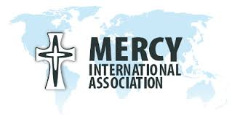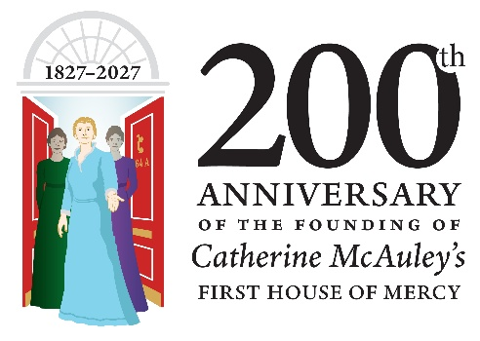
1 March 2026

