**Mercy Day**

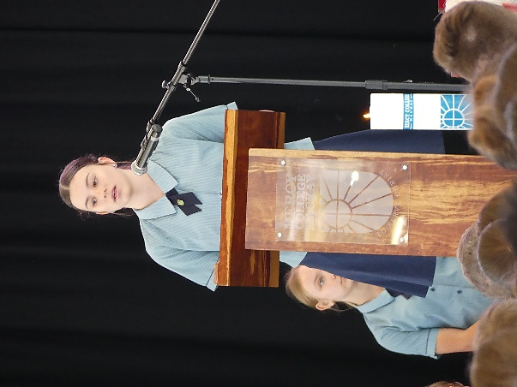Mercy Day is an important day for all of us who belong to a College founded by the Sisters of Mercy. Mercy Day (actual date is 24 September) is the feast of Our Lady of Mercy. It’ss a special day to give thanks to God through Mary for the gift of mercy.

It is also a day to remember and give thanks for the life of Catherine McAuley. On that day in 1827 Catherine’s House of Mercy, in Baggot St, Dublin was opened. Catherine would have been delighted to have a place where her work with the poor could be done.

We celebrated Mercy Day this week and what a wonderful day it was. The day commenced with Mass and we were blest to have the Sisters of Mercy, special guests and the parents of our Mercy Encouragement Awardees join us as our community celebrated Mass along with the award ceremony that followed.

Ashwin, the student priest in our Southern Cluster shared the reflection on the readings.

*His reflection involved a story with the main character, a good guy, being “God.” Of course God creates beauty, order, harmony, peace, teeming with life. He creates family, he creates creatures ‘humans’ which are meant to be unconditionally loving, believing and hoping, in a certain sense, for the best… Whatever may happen, God decides to give them freedom and at the outset to shower them with everything they could possibly need to choose life and love and joy.… but they turn away, and reject God.* ***What a tragedy!***

*he creatures enjoy their freedom, taking what they need from God but rejecting God’s company; starting families of their own but refusing to be part of his; living for a short time, and like water cut off from the stream, their love and life starts to go stagnant… what began as love turns into selfishness, violence, disharmony… and the world which God created – beautiful, ordered, harmonious and peaceful - has become ugly, disordered, without harmony and full of chaos… It’s a good thing God has pledged humanity his help come whatever…*

*The humans actually see this mess as God’s fault! But even as they blame God, they cry out “Have mercy on us!” It’s a good thing our main character has already pledged, through thick or thin, rain or shine, to help humanity always and in every way.*

*Plot twist: another character emerges. Even though not the main character, she is incredibly important. This character is totally unique and responded to God’s invitation to family, to life, to love… she is able to say “Yes.” She is above the influence of the darkness, and uses her freedom to choose light and life and love. In our story, she has been given a special part, not just for her, but for everyone’s sake. Through this mysterious woman, we see God’s desire for* ***“a loving family living peacefully in a perfect world”*** *take shape.*

**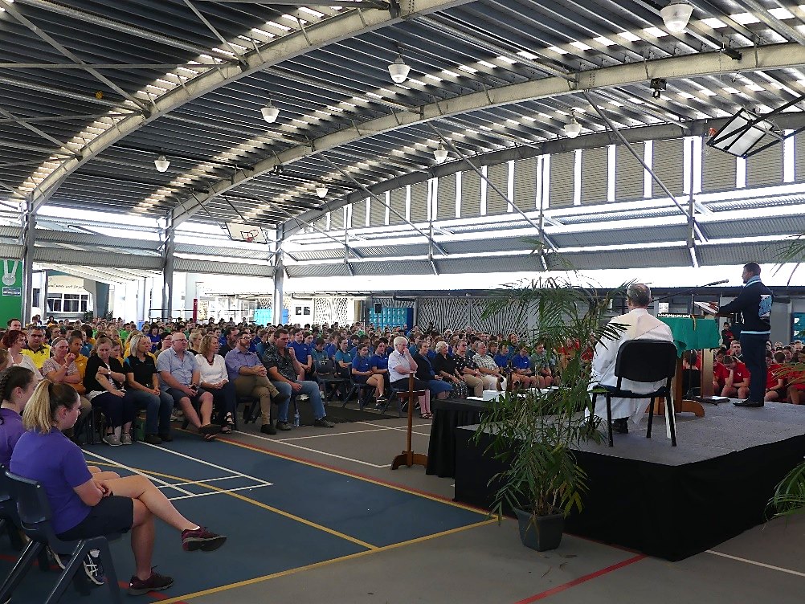***Our story has now come to a head: God the Father choses this woman, named Mary, to be the mother of Jesus, God’s son. Mary says “Yes.” Jesus is born, grows up, teaches the world about God, and shows the world what God’s love looks like – that is to say, shows the world God’s mercy. In fact, God the Father has been called Mercy before, and Jesus has been called the Face of Mercy. It is little wonder then that Mary is hailed as Our Lady of Mercy, with her many children bearing in their hearts the Light of Mercy, the light of God’s love and life, the light for which the world cries out.*

**Mrs Jeanette Refalo**

**Assistant Principal Mission**

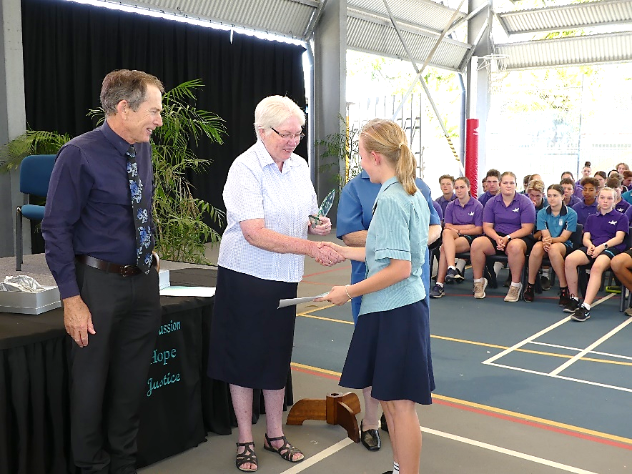**Mercy in Action Encouragement Award**

The Annual Mercy in Action Encouragement Award, is awarded to a student from each of Years 7,8, and 9.  This year we have two awardees for Year 8.

The students receiving the award today have been identified as living out the Mercy values of Hope, Compassion and Justice for the poor and vulnerable.  This annual award acknowledges the continuation of the work of Catherine McAuley who saw a need and did something about it.

In addition to recognising the efforts of the award recipients we encourage them and all students to strive to initiate social justice projects in our College and take them out into society.

**Congratulations to the Awardees:**

